ACIT 3640 – Part 2
AWS IAM User Management

- Activating MFA (multi-factor authentication) on your root account.
  - This part requires that you have a mobile (cell) phone.
  - Log into your AWS with your root account (...@ mybcit.ca account )
  - Download and install a virtual MFA application to your mobile device. See list in screen shot below. Given the choice, always select Google Authenticator.
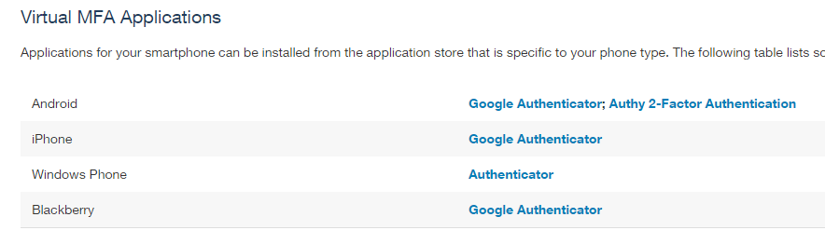
  - On the AWS Console, click on IAM or type “IAM “into the AWS Services search window.
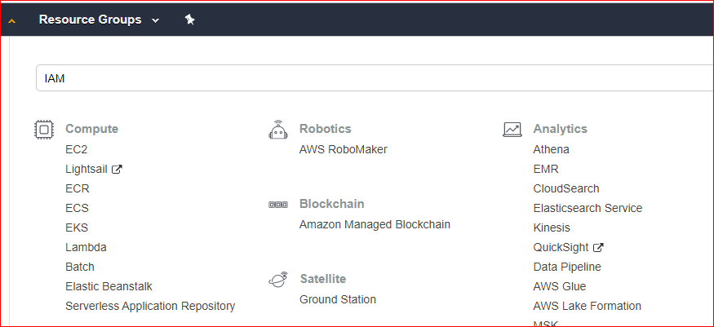
  - Under “Active MFA on your root account” click on Manage MFA.
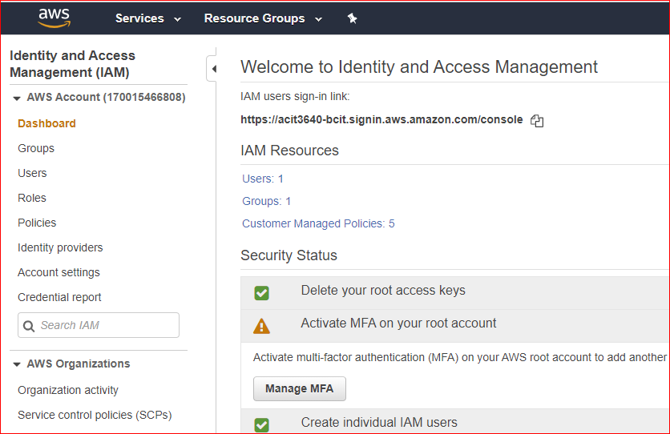
  - Click on “continue to security credentials”
  - Under “Multi-factor authentication (MFA)” select “Active MFA”.
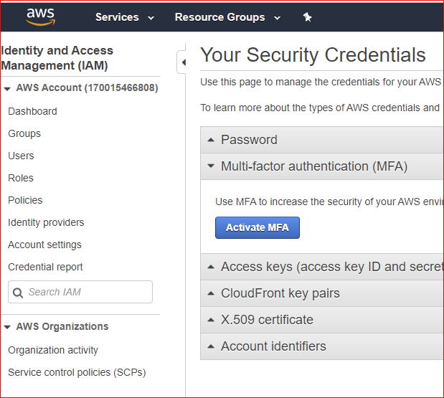
  - Choose “virtual MFA device”.
  - . From the wizard, choose Show QR code and use the authenticator on your mobile device to scan the barcode.
  - You will be required to enter two numbers. Wait up to 30 seconds for your mobile to generate second MFA code.
  - Refresh the webpage to verify that MFA was successful.
  - Now, when you log into your root account, you will be asked to enter your Authentication Code generated from your mobile device:
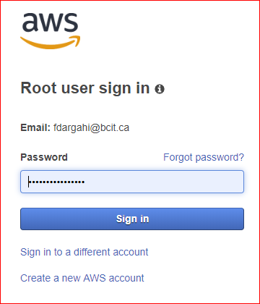

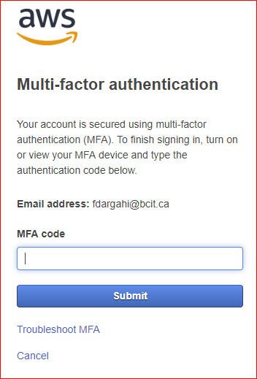
- Customize sign in link for new IAM user:
  - Type “IAM “into the AWS Services search window and go to the IAM dashboard.
  - Click on Customize to the right of IAM user sign-in link.
  - Change the name of the sign-in link to make it easy to remember. I used “acit3640-bcit”. Use your student Id, A00… . Must be unique across all regions!
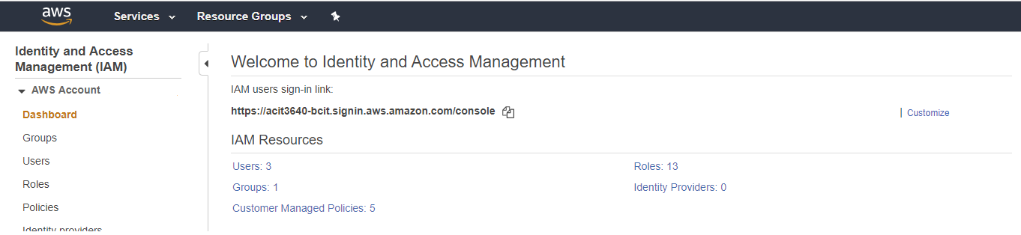

- Create a new, AWS individual IAM user:
  - This will be the user you will use most of the time to sign in.
  - You will use it in combination with the IAM users sign-in link.
  - On the left, select Users and click “Add user.”
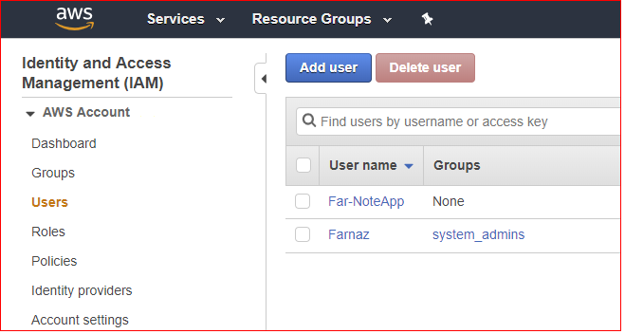
  - Enter a user name. I suggest your first name.
  - Select Programmatic access and AWS Management console access.
  - Enter a custom password and uncheck “require password reset.
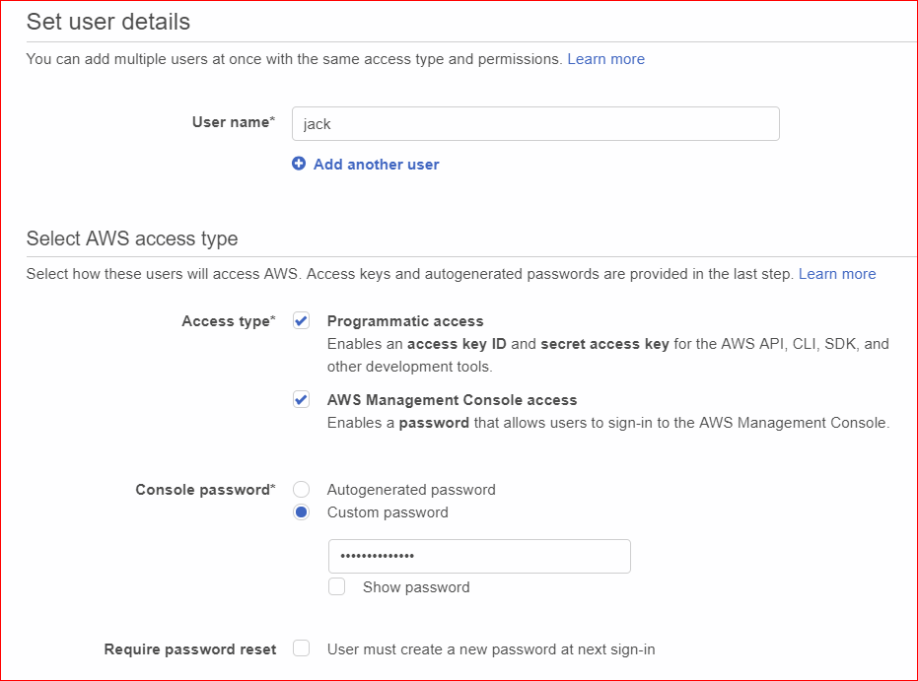
  - Click Next:Permissions.
  - Click “Attach existing policies directly.
  - Click the policy “AdministratorAccess”.
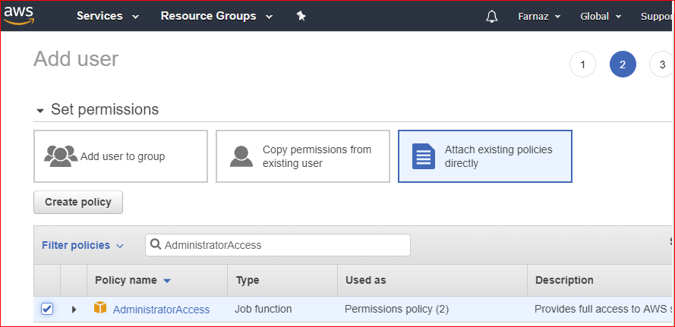
  - Click “Next:Tag” in lower right corner.
  - Click “Next:Review” in lower right corner.
  - Then click “Create user.”
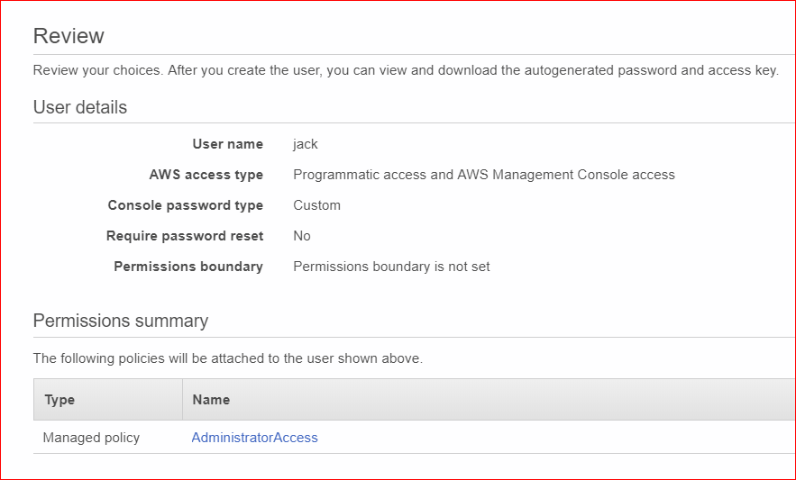
  - Download the CSV file containing the Access key ID and Secret access key.
    - It also contains the sign-in link.
    - Save this in a secure place!
    - If you lose this file, you will have to delete the user and recreate the user.
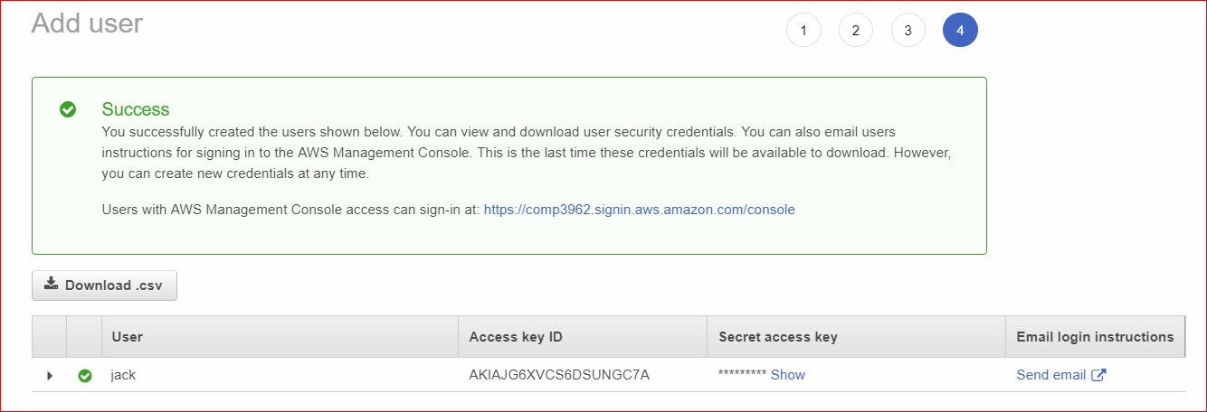
  - Click the “Send email” button the right. It will contain the login link for your new user. 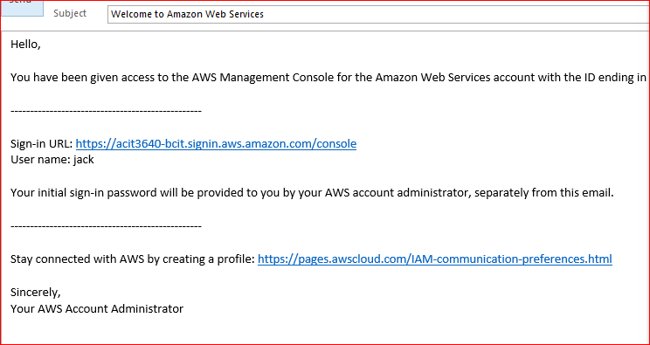
- Enable MFA for this new user:
  - Click Users on the left.
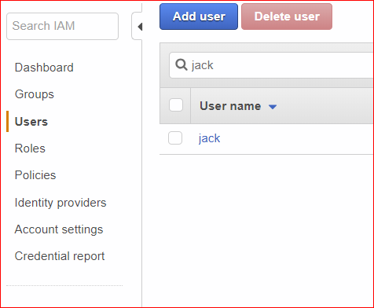
  - Click on the user.
  - Click the “Security credentials” tab.
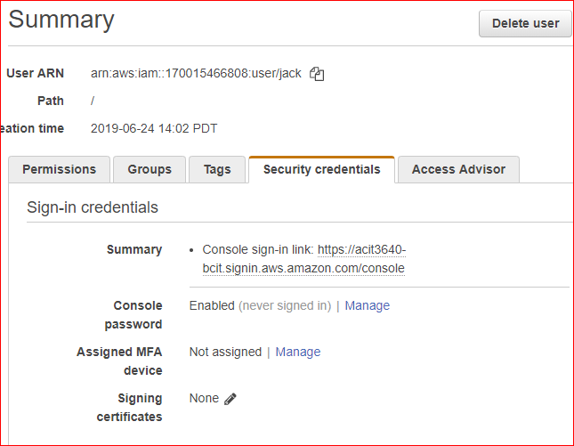
  - In the middle of the screen, look at “Assigned MFA device.” Currently set to No.
  - Click on Manage to enable MFA on this account.
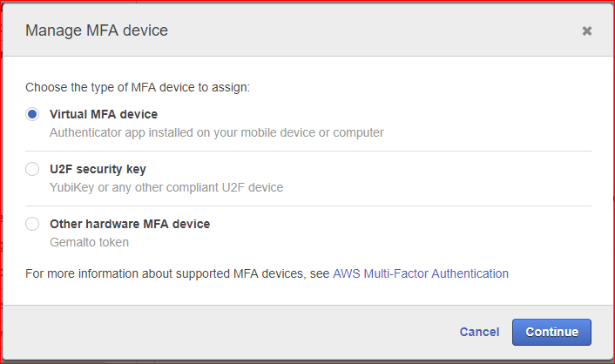
  - When you sign in using the IAM sign-in URL and the user name, you will not receive a text message with the authentication code. You must go to the Authenticator app and use the six-digit code that is displayed in the app.
  - Finally, sign in using the link in your email and the new user.
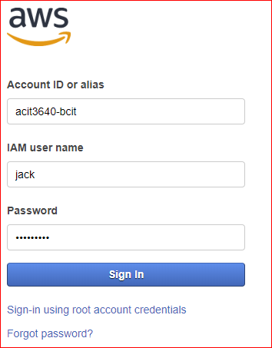
  - You will be prompted to enter an MFA Code as before.

